**Tutorial questions 7**

1. Find $\frac{∂f}{∂x} , \frac{∂f}{∂y}$ for the function:
$$a) f\left(x,y\right)=x\cos{y }+ye^{3x+2y}$$

$$b) f\left(x,y\right)=y^{3}\sin{(xy)}$$

2. Find $\frac{∂f}{∂x} , \frac{∂f}{∂y} , \frac{∂f}{∂z}$ for the function:
$$f\left(x,y,z\right)=x\cos{z}+x^{2}y^{3}e^{z}$$

3. Find $\frac{∂^{2}f}{∂x^{2}} , \frac{∂^{2}f}{∂y^{2}}$ for the function:

$$a) f\left(x,y\right)=x^{2}\sin{y}+y^{2}\cos{x}$$

$$b) f\left(x,y\right)=\left(\frac{y}{x}\right)\ln{x}$$

1. Use the chain rule to find $\frac{∂f}{∂s} and \frac{∂f}{∂t}$, for the function
$$f\left(x,y\right)=x^{2}-2xy+2y^{3} with x=s^{2}\ln{t} , y=2st^{3}$$

2. Show that $u=\ln\left(1+xy^{2}\right)$ is a solution of the partial differential equation

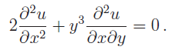

1. Find all stationary points of the function and determine their nature:

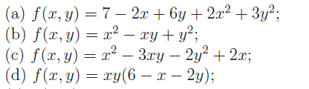

1. A container with an open top is to have 10 $m^{3}$ capacity and be made of thin sheet metal. Calculate the dimensions of the box if it is to use the minimum possible amount of metal.